Faith Lutheran Church in Valders

Sharing God’s Word; Showing God’s Love; Serving God’s World.

25th Sunday after Pentecost

November 14, 2021

Gathering
Welcome and Announcements
Video Today We Honor Our Veterans

P: We begin our worship in the name of the
Father, and of the Son, and of the Holy
Spirit.
C: Amen.

P: Most gracious God, as we gather in your
presence we pray,
C: That out of your glorious riches you will strengthen us through the power of your Holy Spirit in our inner being, so that Christ may dwell in our hearts through faith. And may we, being rooted and grounded in love, be able to grasp how wide and long and high and deep is the love of Christ, and to know this love that surpasses knowledge – that we may be filled with all the fullness of God. (Ephesians 3:16-19)

P: May you be strong in the grace that is in
Christ Jesus. (2 Timothy 2:1)

Opening Song “For the Beauty of the Earth”
vs. 1, 2, 4 #879

P: The grace of the Lord Jesus Christ, the love
of God, and the communion of the Holy
Spirit be with you all.
C: And also with you.

Prayer of the Day
P: Let us pray.
C: Lord God, you speak to us through the Holy Scriptures. Grant that we may hear, read, respect, learn, and make them our own in such a way that we understand and follow your commands, loving you and our neighbors as ourselves, through Jesus Christ our Savior. Amen.
Baptism of Hadley Rey Beckman

P: Do you believe in God the Father?
C: I believe in God, the Father almighty,
creator of heaven and earth.

P: Do you believe in Jesus Christ, the Son of
God?
C: I believe in Jesus Christ, God's only Son, our Lord, who was conceived by the Holy Spirit, born of the virgin Mary, suffered under Pontius Pilate, was crucified, died, and was buried; he descended to the dead. On the third day he rose again; he ascended into heaven, he is seated at the right hand of the Father, and he will come to judge the living and the dead.

P: Do you believe in God the Holy Spirit?
C: I believe in the Holy Spirit, the holy Christian Church, the communion of saints, the forgiveness of sins, the resurrection of the body, and the life everlasting. Amen.

Baptismal Song “Borning Cry” #732

The Scriptures
First Reading: Deuteronomy 6:3 – 9
Hear, Israel, and be careful to obey so that it may go well with you and that you may increase greatly in a land flowing with milk and honey, just as the LORD, the God of your ancestors, promised you.
Hear, O Israel: The LORD our God, the LORD is one. Love the LORD your God with all your heart and with all your soul and with all your strength. These commandments that I give you today are to be on your hearts. Impress them on your children.
Talk about them when you sit at home and when you walk along the road, when you lie down and when you get up. Tie them as symbols on your hands and bind them on your foreheads. Write them on the doorframes of your houses and on your gates.
L: The Word of the Lord.
C: Thanks be to God.

Second Reading: Romans 13:8 – 14
Let no debt remain outstanding, except the continuing debt to love one another, for whoever loves others has fulfilled the law.
The commandments, “You shall not commit adultery,” “You shall not murder,” “You shall not steal,” “You shall not covet,” and whatever other command there may be, are summed up in this one command: “Love your neighbor as yourself.” Love does no harm to a neighbor. Therefore, love is the fulfillment of the law.
And do this, understanding the present time: The hour has already come for you to wake up from your slumber, because our salvation is nearer now than when we first believed. The night is nearly over; the day is almost here. So, let us put aside the deeds of darkness and put on the armor of light. Let us behave decently, as in the daytime, not in carousing and drunkenness, not in sexual immorality and debauchery, not in dissension and jealousy. Rather, clothe yourselves with the Lord Jesus Christ, and do not think about how to gratify the desires of the flesh.
L: The Word of the Lord.
C: Thanks be to God.

Gospel Song “Breathe on Me Breath of God”
Breathe on me Breath of God,
Fill me with life anew,
That I may love the way you love,
And do what thou wouldst do.

The Gospel: Mark 12:28 – 34
One of the teachers of the law came and heard them debating. Noticing that Jesus had given them a good answer, he asked him, “Of all the commandments, which is the most important?”
“The most important one,” answered Jesus, “is this: ‘Hear, O Israel: The Lord our God, the Lord is one. Love the Lord your God with all your heart and with all your soul and with all your mind and with all your strength.’ The second is this: ‘Love your neighbor as yourself.’ There is no commandment greater than these.”
“Well said, teacher,” the man replied. “You are right in saying that God is one and there is no other but him. To love him with all your heart, with all your understanding and with all your strength, and to love your neighbor as yourself is more important than all burnt offerings and sacrifices.”
When Jesus saw that he had answered wisely, he said to him, “You are not far from the kingdom of God.” And from then on no one dared ask him any more questions.
P: The Gospel of our Lord. C: Praise to you, O Christ.

MESSAGE “The Greatest Commandments”

Song of Response “Ancient Words”

Holy words, long preserved, for our walk, in this world, they resound, with God’s own heart, O let the ancient words impart. Words of life, words of hope, give us strength, help us cope, in this world, where’er we roam, ancient words will guide us home.

Chorus: Ancient words ever true, changing me, and changing you. We have come, with open hearts, O let the ancient words impart.

Holy words, of our faith, handed down, to this age, came to us, through sacrifice, O heed the faithful words of Christ. Holy words, long preserved, for our walk, in this world, they resound, with God’s own heart, O let the ancient words impart. Chorus 2X
©2001 Integrity’s Hosanna! Music / ASCAP Used by permission All rights reserved. Reprinted under One License #A-722337

PRAYERS OF INTERCESSION
Lord, in your mercy, hear our prayer.

P: Into your hands, O LORD, we commend all
for whom we pray, trusting in your mercy and
love that we know we have through Jesus
Christ our Savior and Lord.
C: Amen.

Lord’s Prayer
Our Father who art in heaven, hallowed be thy name, thy kingdom come, thy will be done on earth as it is in heaven. Give us this day our daily bread, and forgive us our trespasses, as we forgive those who trespass against us; and lead us not into temptation, but deliver us from evil, for thine is the kingdom, the power and the glory, forever and ever. Amen.

Benediction
Closing Song
“Mine Eyes Have Seen the Glory” #890
P: Go in the Spirit of Christ to love and serve
the Lord.
C: Sharing God’s Word, Showing God’s
Love, and Serving God’s World.
***************************************
Serving Us Today
Greeter: Wayne Huske
Head Usher: Scott Reinerston
Ushers: Dean and Rose Behnke Family
Acolyte: Whitney Ulness
Lector: Clarissa Ulness
Sound Operator: Bill Riesterer
Projection: Carter Lenzner
Video/Live Stream: Bill Riesterer & Hunter Spindler
Serving Us Next Week
Greeter: Mitchell Zutz
Head Usher: Scott Reinertson
Ushers: Tom and Kathy Muench Acolyte: Mollie Junk
Lector and Communion Aide: Judy Harris
Video and Live Stream: Jake Kaderabek
Projection: Luke Evenson
Sound Operator: Erin Lenzner

Last Week – Sunday: 147 Video: 110
Wednesday: 41
Offerings to the Lord’s work: $6,758.00

Known to have been hospitalized or in need of prayer: Marlene Thomsen, Dennis Evenson, Lynn Burzynski, Ray Rusch, Harry Kwasny, Connie Schisel, Donald Tienor, Lorraine Reindl, Delores Johnson, Ginger Linsmeier, Bob Klessig, Doug Wilson, Ivan Madson, Ronald Christianson, Elling Jones (brother of Ron Jones), Merle “Butch” Graf, Wayne Allen Huske.

Please keep in your thoughts and prayers the following who are serving in the military: Daniel Brandl, Matthew Brill, Kyle and Dylan Conrad, Corey Evenson, Carter Hildebrandt, Jeff Konz and Andy Schnell. If there are others we should be remembering, please inform the church office.

Faith’s Opportunities November 14-21
Sunday 10:00 A.M. Sunday School, Fellowship
10:15 A.M. 9th gr. Confirmation
Monday Newsletter info due to office
6:00 P.M. Tel. Worship/Jazzercise
6:30 P.M. Council
Tuesday 9:00 A.M. Senior Christians at Whispering Orchards
Wednesday 6:00 P.M. Card Club
6:15 P.M. Worship
7:00 P.M. 7 & 8th gr. Confirmation
Thursday 8:00 A.M. Quilting
6:00 P.M. Jazzercise
Friday 10:00 A.M. Lefse Making
Saturday 9:00 A.M. Lefse orders filled
Sunday 9:00 A.M. Worship
10:00 A.M. Sunday School, Fellowship Hour

The 2022 offering envelopes are arranged alphabetically on tables in the Gathering Space. Please secure yours today. If you can take envelopes for another family member or friend, please do so. This will save on mailing costs. Thank you.

This morning, we welcome Hadley Rey Beckman into God’s kingdom and our congregation through Holy Baptism. Hadley Rey was born August 5 to Dan and Abby Beckman and her baptismal sponsors are Matthew Brill and Danielle Simon. Grandparents are Brian and Tammy Brill and John and Lora Murphy. Great grandparents are Dick and Linda Menza and Ralph and Judy Brill. We rejoice at Hadley’s rebirth through water and the Word!

Staffing the Information Desk
The Board of Evangelism is experimenting with having a congregational member available at the Welcome Desk for 15-20 minutes prior to Sunday service. The duties included with this ministry opportunity would be to be on “high alert” for visitors and potential new members. There is a direct correspondence to a potential return to a church based on how welcome and helpful the congregation was during an initial visit. Additionally this person would be equipped with the knowledge to answer basic questions from visitors and congregation members or to be able to direct questions to the most helpful staff member/individual. We will be actively recruiting people for this important ministry. Please prayerfully consider your involvement and contact Christine in the church office you would like to be of part of this.

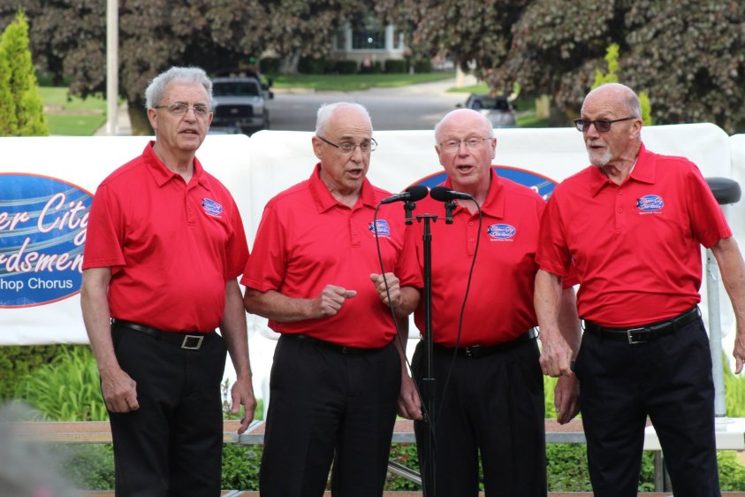
A Touch of Harmony Quartet
will be with us in worship Sunday, November 21 at 9:00 a.m. Join Us!

Our Sunday school year is off to a great start! The kids are enjoying the new format and those that have volunteered to teach have noted that the lessons are easy to prepare for and fun to present. We are in need of more adults to sign up to help teach in November and December. The signup sheets are on the bulletin board outside of the office and the lesson plans can be found downstairs across from the Men's room. Please consider signing up to help our youth today!

Imagine the comfort that comes with a hug when someone is in a time of deepest need. Through a simple combination of fabric and thread the Quilting Ladies at Faith have reached out to those with some of the greatest needs in the world, not wrapping them in their arms, but wrapping them in the work of their hands through the making of quilts.
We feel the warmth from the following ladies who have worked all year completing the task of making quilts. Now when you see Cheryl Domrath, Marlene Evenson, Kayleen Halderson (Coordinators), Gladys Hansen, Bev Hildebrandt, Linda Menza, Virginia Meyer, Jo Jones, Mardell Huske, Ann DeMark, Janice Dill, Sharon Schuh, Teresa Pederson and Gladys Tienor, extend to them a BIG THANK YOU for all they do to meet the needs of people they will never meet. These quilts will be distributed at Christmas to the Salvation Army, The Haven, Hope House, The Crossing, Faith’s Pantry and In Courage.
If anyone wishes to donate to our quilting fund, so we can continue to purchase warm batting, envelopes are available on the back table and can be turned into the church office.

Please have all items for this year’s Sharing Tree to church (unwrapped) by Tuesday, November 23. Any questions can be directed to Julie Endries at 920-973-9881. Thank you for your support of this outreach project!

In the Gathering Space is a list of items wished for by the Manitowoc Health Care and Rehabilitation Center. Please have all items back to church by November 30.

