Serving Us Tonight
Greeter: Judy Valleskey Lector: Carol Ulness
Projection: Libby Olson

Serving Us Next Week
Greeters: Scott and Nicole Zucchi Family
Lector & Communion Aide: Sue Christel

Last Week – Sunday: 108 Video: 67 Wednesday: 33
Offerings to the Lord’s work: $6,245.00

Known to have been hospitalized or in need of prayer: Gorman Lex, Lorraine Reindl, Delores Johnson, Cathy Luckow, Ginger Linsmeier, Bob Klessig, Ron Gilbertson, Elling Jones (brother of Ron Jones), Merle “Butch” Graf, Wayne Allen Huske.

Please keep in your thoughts and prayers the following who are serving in the military: Daniel Brandl, Matthew Brill, Kyle and Dylan Conrad, Corey Evenson, Mitchell Hazelwood, Carter Hildebrandt, Jeff Konz, Justin Mertzig and Andy Schnell. If there are others we should be remembering, please inform the church office.

Send well wishes to our homebound members by signing the greeting cards on the table in the Gathering Space.

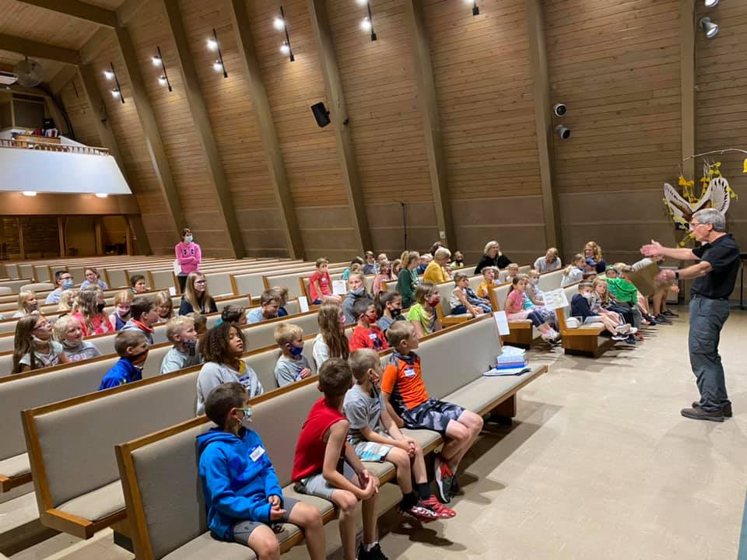

Learning about Jesus and Ananias at Vacation Bible School.

Faith’s Opportunities June 24-30
Thursday 6:00 P.M. Jazzercise
Saturday 10:00 A.M. Celebration of Life/Gilbertson Family
Sunday 9:00 A.M. Worship
10:00 A.M. Fellowship Hour
Monday 6:00 P.M. Televised Worship & Jazzercise
Wednesday 6:15 P.M. Worship

As part of our 60th year celebration of coming together as one congregation of Faith, each week we will look at the symbolism around our church sculpted by O. V. Schaffer.

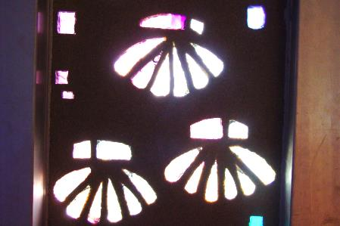
The Fellowship Hall Window
The escallop shell denotes
pilgrimage and is the usual
symbol of St. James the Creator.

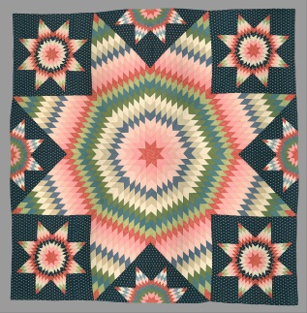
Valders Faithful Quilters, an ecumenical group, work in the Fellowship Hall Thursday mornings from 8:00AM until 11:30AM. The ladies rip, trim, iron, sew pieces together, pin sides together, sew around and tie with yarn to complete the quilts. You do not need any sewing abilities to help. If you have any questions, please contact Cheryl Domrath at 684-5127. Any help is appreciated. Materials needed: large pieces of new or good used fabric, except fiberglass. Old bed sheets for fillers. Clean material only please. Thread for machine sewing, white polyester (Wal-Mart works best). Bright colored yarn. Donated material should be clearly marked Quilting and left downstairs under the coat rack.

Serving Us Tonight
Greeter: Judy Valleskey Lector: Carol Ulness
Projection: Libby Olson

Serving Us Next Week
Greeters: Scott and Nicole Zucchi Family
Lector & Communion Aide: Sue Christel

Last Week – Sunday: 108 Video: 67 Wednesday: 33
Offerings to the Lord’s work: $6,245.00

Known to have been hospitalized or in need of prayer: Gorman Lex, Lorraine Reindl, Delores Johnson, Cathy Luckow, Ginger Linsmeier, Bob Klessig, Ron Gilbertson, Elling Jones (brother of Ron Jones), Merle “Butch” Graf, Wayne Allen Huske.

Please keep in your thoughts and prayers the following who are serving in the military: Daniel Brandl, Matthew Brill, Kyle and Dylan Conrad, Corey Evenson, Mitchell Hazelwood, Carter Hildebrandt, Jeff Konz, Justin Mertzig and Andy Schnell. If there are others we should be remembering, please inform the church office.

Send well wishes to our homebound members by signing the greeting cards on the table in the Gathering Space.

Learning about Jesus and Ananias at Vacation Bible School.

Faith’s Opportunities June 24-30
Thursday 6:00 P.M. Jazzercise
Saturday 10:00 A.M. Celebration of Life/Gilbertson Family
Sunday 9:00 A.M. Worship
10:00 A.M. Fellowship Hour
Monday 6:00 P.M. Televised Worship & Jazzercise
Wednesday 6:15 P.M. Worship

As part of our 60th year celebration of coming together as one congregation of Faith, each week we will look at the symbolism around our church sculpted by O. V. Schaffer.

The Fellowship Hall Window
The escallop shell denotes
pilgrimage and is the usual
symbol of St. James the Creator.

Valders Faithful Quilters, an ecumenical group, work in the Fellowship Hall Thursday mornings from 8:00AM until 11:30AM. The ladies rip, trim, iron, sew pieces together, pin sides together, sew around and tie with yarn to complete the quilts. You do not need any sewing abilities to help. If you have any questions, please contact Cheryl Domrath at 684-5127. Any help is appreciated. Materials needed: large pieces of new or good used fabric, except fiberglass. Old bed sheets for fillers. Clean material only please. Thread for machine sewing, white polyester (Wal-Mart works best). Bright colored yarn. Donated material should be clearly marked Quilting and left downstairs under the coat rack.

