Serving Us Today
Greeters: Paul and Jill Franz Head Usher: Paul Franz
Usher: Steve Ahrens Acolyte: Peter Cigler
Lector: Tiffany Jandrey Sound Operator: Jackie Shimek
Projection: Judy Harris Live Stream & Video Operator: Bill Riesterer
Serving Us Next Week
Greeter: Paul and Jill Franz Head Usher: Scott Reinertson
Usher: Dean Behnke Acolyte: Mollie Junk
Lector and Communion Aide: Judy Harris
Video and Live Stream: Carter Lenzner
Sound and Projection: Erin Lenzner, Lucas Spindler, Addison Spindler

Last Week – Sunday: 72 Video: 85 Wednesday: 31
Offerings to the Lord’s work: $3,444.00

Known to have been hospitalized or in need of prayer: : The family of Donald Schisel who passed away May 22, Gorman Lex, Lorraine Reindl, Delores Johnson, Cathy Luckow, Ginger Linsmeier, Bob Klessig, Elling Jones (brother of Ron Jones), Julia Quinn (granddaughter of Julie Dehne), Merle “Butch” Graf, Wayne Allen Huske.

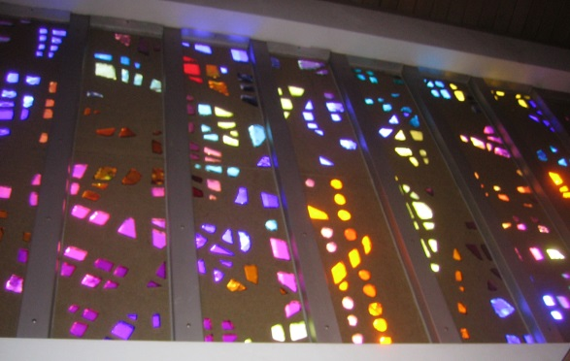
Please keep in your thoughts and prayers the following who are serving in the military: Darcie Bauknecht, Daniel Brandl, Matthew Brill, Kyle and Dylan Conrad, Corey Evenson, Mitchell Hazelwood, Carter Hildebrandt, Jeff Konz, Justin Mertzig and Andy Schnell. If there are others we should be remembering, please inform the church office.

All high school seniors and families are invited to:
THE VALDERS AREA BACCALAUREATE SERVICE
Sunday, June 6 at 12:30 p.m.
Together we will ask for guidance and blessings for our graduates. Graduates need to be dressed in their cap and gown and in the Gathering Space by 12:15 P.M.

A caregiver is needed for a man with dementia four days a week; Monday and Tuesday from 5:00-10:00 p.m. and Wednesday and Thursdays from 2:30-10:00 p.m. Please call Becki at 920-288-2105 and leave a message if interested.

Faith’s Opportunities May 30-June 6
Sunday 10:00 A.M. Fellowship Hour
Monday Office Closed – Memorial Day observed
6:00 P.M. Televised Worship & Jazzercise
Tuesday 6:00 P.M. Board of Evangelism
Wednesday 6:15 P.M. Worship
Thursday 8:00 A.M. Quilting
6:00 P.M. Jazzercise
Sunday 9:00 A.M. Worship
10:00 A.M. Fellowship Hour

All aboard! Rocky Railway VBS is in need of some additional cargo and supplies. Please take a moment to check out the luggage tags at the entrance to the sanctuary to see what is needed. If you are able to help, simply sign your name on the tag and take the attached post it as a reminder for yourself. Supplies can be left in the Youth Office at church prior to May 30. We appreciate your support and can’t wait to get this train heading down the rails!

As part of our 60th year celebration of coming together as one congregation of Faith, each week we will look at the symbolism around our church sculpted by O. V. Schaffer.

The Choir Loft
The colorful window area which forms a background for the choir loft speaks to us of David, the shepherd boy, sweet singer, author of the Psalms, represented by his harp. These same psalms form an integral part of Christian liturgy and hymnody today.

Serving Us Today
Greeters: Paul and Jill Franz Head Usher: Paul Franz
Usher: Steve Ahrens Acolyte: Peter Cigler
Lector: Tiffany Jandrey Sound Operator: Jackie Shimek
Projection: Judy Harris Live Stream & Video Operator: Bill Riesterer
Serving Us Next Week
Greeter: Paul and Jill Franz Head Usher: Scott Reinertson
Usher: Dean Behnke Acolyte: Mollie Junk
Lector and Communion Aide: Judy Harris
Video and Live Stream: Carter Lenzner
Sound and Projection: Erin Lenzner, Lucas Spindler, Addison Spindler

Last Week – Sunday: 72 Video: 85 Wednesday: 31
Offerings to the Lord’s work: $3,444.00

Known to have been hospitalized or in need of prayer: : The family of Donald Schisel who passed away May 22, Gorman Lex, Lorraine Reindl, Delores Johnson, Cathy Luckow, Ginger Linsmeier, Bob Klessig, Elling Jones (brother of Ron Jones), Julia Quinn (granddaughter of Julie Dehne), Merle “Butch” Graf, Wayne Allen Huske.

Please keep in your thoughts and prayers the following who are serving in the military: Darcie Bauknecht, Daniel Brandl, Matthew Brill, Kyle and Dylan Conrad, Corey Evenson, Mitchell Hazelwood, Carter Hildebrandt, Jeff Konz, Justin Mertzig and Andy Schnell. If there are others we should be remembering, please inform the church office.

All high school seniors and families are invited to:
THE VALDERS AREA BACCALAUREATE SERVICE
Sunday, June 6 at 12:30 p.m.
Together we will ask for guidance and blessings for our graduates. Graduates need to be dressed in their cap and gown and in the Gathering Space by 12:15 P.M.

A caregiver is needed for a man with dementia four days a week; Monday and Tuesday from 5:00-10:00 p.m. and Wednesday and Thursdays from 2:30-10:00 p.m. Please call Becki at 920-288-2105 and leave a message if interested.

Faith’s Opportunities May 30-June 6
Sunday 10:00 A.M. Fellowship Hour
Monday Office Closed – Memorial Day observed
6:00 P.M. Televised Worship & Jazzercise
Tuesday 6:00 P.M. Board of Evangelism
Wednesday 6:15 P.M. Worship
Thursday 8:00 A.M. Quilting
6:00 P.M. Jazzercise
Sunday 9:00 A.M. Worship
10:00 A.M. Fellowship Hour

All aboard! Rocky Railway VBS is in need of some additional cargo and supplies. Please take a moment to check out the luggage tags at the entrance to the sanctuary to see what is needed. If you are able to help, simply sign your name on the tag and take the attached post it as a reminder for yourself. Supplies can be left in the Youth Office at church prior to May 30. We appreciate your support and can’t wait to get this train heading down the rails!

As part of our 60th year celebration of coming together as one congregation of Faith, each week we will look at the symbolism around our church sculpted by O. V. Schaffer.

The Choir Loft
The colorful window area which forms a background for the choir loft speaks to us of David, the shepherd boy, sweet singer, author of the Psalms, represented by his harp. These same psalms form an integral part of Christian liturgy and hymnody today.

