Serving Us Today
Greeter: Ron and Kaye Jandrey Head Usher: Scott Reinertson
Ushers: Tom and Kathy Muench Acolyte: Gage Spindler
Lector and Communion Aide: Joan Pritzl
Video and Live Stream: Mike Lenzner Projection: Luke Evenson
Sound Operators: Loren Ulness and Makenna Kaderabek
Serving Us Next Week
Greeters: Keith and Audrey Lippert Head Usher: Scott Reinertson
Ushers: Earl and Barb Griffin Acolyte: Whitney Ulness
Lector: Chase Wilker Sound Operator: Terry Huske
Projection: Terry Huske
Live Stream & Video Operator: Travis Schisel

Last Week – Sunday: 50 Video: 72 Wednesday: 33
Offerings to the Lord’s work: $5,590.00

Known to have been hospitalized or in need of prayer: Gorman Lex, Lorraine Reindl, Delores Johnson, Cathy Luckow, Ginger Linsmeier, Bob Klessig, Ron Gilbertson, Elling Jones (brother of Ron Jones), Merle “Butch” Graf, Wayne Allen Huske.

Please keep in your thoughts and prayers the following who are serving in the military: Daniel Brandl, Matthew Brill, Kyle and Dylan Conrad, Corey Evenson, Mitchell Hazelwood, Carter Hildebrandt, Jeff Konz, Justin Mertzig and Andy Schnell. If there are others we should be remembering, please inform the church office.

This morning, we welcome Ella Lynn Hammel into God’s kingdom and our congregation through Holy Baptism. Ella was born May 5 to Dustin and Samantha and her baptismal sponsors are Brian Schaeuble and Dylan Hammel. Grandparents are Richard Schaeuble, Shari and Brian Riesterer and Dan and Ginger Hammel. Great-grandparents are Jacqueline Lauers and Carol Zutz. We rejoice at Ella’s rebirth through water and the Word!

Send well wishes to our homebound members by signing the greeting cards on the table in the Gathering Space.

The congregation is invited to the VBS supper on Friday, June 25 at 5:00pm in the fellowship hall. We will have sub sandwiches and all the fixin’s along with chips, dessert, milk and ice cream. Please sign up on the sheet at the Information Desk or call the church office so we know how many subs to order.
Faith’s Opportunities June 20-27
Sunday 10:00 A.M. Fellowship Hour
Monday 12:30-4:00 P.M. Vacation Bible School
6:00 P.M. Televised Worship & Jazzercise
6:30 P.M. Council
Tuesday 12:30-4:00 P.M. Vacation Bible School
Wednesday 12:30-4:00 P.M. Vacation Bible School
6:15 P.M. Worship
Thursday 12:30-4:00 P.M. Vacation Bible School
6:00 P.M. Jazzercise
Friday 12:30-4:00 P.M. Vacation Bible School
5:00 P.M. VBS Supper in Fellowship Hall
Sunday 9:00 A.M. Worship
10:00 A.M. Fellowship Hour

As part of our 60th year celebration of coming together as one congregation of Faith, each week we will look at the symbolism
around our church sculpted by O. V. Schaffer.

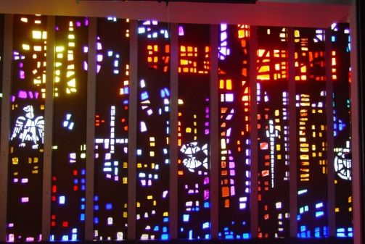
The Fellowship Hall Window

Here we see Christ on the Cross
- the price of our salvation.

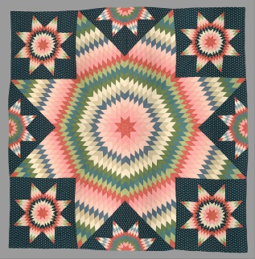
Valders Faithful Quilters, an ecumenical group, work in the Fellowship Hall Thursday mornings from 8:00AM until 11:30AM. The ladies rip, trim, iron, sew pieces together, pin sides together, sew around and tie with yarn to complete the quilts. You do not need any sewing abilities to help. If you have any questions, please contact Cheryl Domrath at 684-5127. Any help is appreciated. Materials needed: large pieces of new or good used fabric, except fiberglass. Old bed sheets for fillers. Clean material only please. Thread for machine sewing, white polyester (Wal-Mart works best). Bright colored yarn. Donated material should be clearly marked Quilting and left downstairs under the coat rack.

Serving Us Today
Greeter: Ron and Kaye Jandrey Head Usher: Scott Reinertson
Ushers: Tom and Kathy Muench Acolyte: Gage Spindler
Lector and Communion Aide: Joan Pritzl
Video and Live Stream: Mike Lenzner Projection: Luke Evenson
Sound Operators: Loren Ulness and Makenna Kaderabek
Serving Us Next Week
Greeters: Keith and Audrey Lippert Head Usher: Scott Reinertson
Ushers: Earl and Barb Griffin Acolyte: Whitney Ulness
Lector: Chase Wilker Sound Operator: Terry Huske
Projection: Terry Huske
Live Stream & Video Operator: Travis Schisel

Last Week – Sunday: 50 Video: 72 Wednesday: 33
Offerings to the Lord’s work: $5,590.00

Known to have been hospitalized or in need of prayer: Gorman Lex, Lorraine Reindl, Delores Johnson, Cathy Luckow, Ginger Linsmeier, Bob Klessig, Ron Gilbertson, Elling Jones (brother of Ron Jones), Merle “Butch” Graf, Wayne Allen Huske.

Please keep in your thoughts and prayers the following who are serving in the military: Daniel Brandl, Matthew Brill, Kyle and Dylan Conrad, Corey Evenson, Mitchell Hazelwood, Carter Hildebrandt, Jeff Konz, Justin Mertzig and Andy Schnell. If there are others we should be remembering, please inform the church office.

This morning, we welcome Ella Lynn Hammel into God’s kingdom and our congregation through Holy Baptism. Ella was born May 5 to Dustin and Samantha and her baptismal sponsors are Brian Schaeuble and Dylan Hammel. Grandparents are Richard Schaeuble, Shari and Brian Riesterer and Dan and Ginger Hammel. Great-grandparents are Jacqueline Lauers and Carol Zutz. We rejoice at Ella’s rebirth through water and the Word!

Send well wishes to our homebound members by signing the greeting cards on the table in the Gathering Space.

The congregation is invited to the VBS supper on Friday, June 25 at 5:00pm in the fellowship hall. We will have sub sandwiches and all the fixin’s along with chips, dessert, milk and ice cream. Please sign up on the sheet at the Information Desk or call the church office so we know how many subs to order.

Faith’s Opportunities June 20-27
Sunday 10:00 A.M. Fellowship Hour
Monday 12:30-4:00 P.M. Vacation Bible School
6:00 P.M. Televised Worship & Jazzercise
6:30 P.M. Council
Tuesday 12:30-4:00 P.M. Vacation Bible School
Wednesday 12:30-4:00 P.M. Vacation Bible School
6:15 P.M. Worship
Thursday 12:30-4:00 P.M. Vacation Bible School
6:00 P.M. Jazzercise
Friday 12:30-4:00 P.M. Vacation Bible School
5:00 P.M. VBS Supper in Fellowship Hall
Sunday 9:00 A.M. Worship
10:00 A.M. Fellowship Hour

As part of our 60th year celebration of coming together as one congregation of Faith, each week we will look at the symbolism
around our church sculpted by O. V. Schaffer.

The Fellowship Hall Window

Here we see Christ on the Cross
- the price of our salvation.

Valders Faithful Quilters, an ecumenical group, work in the Fellowship Hall Thursday mornings from 8:00AM until 11:30AM. The ladies rip, trim, iron, sew pieces together, pin sides together, sew around and tie with yarn to complete the quilts. You do not need any sewing abilities to help. If you have any questions, please contact Cheryl Domrath at 684-5127. Any help is appreciated. Materials needed: large pieces of new or good used fabric, except fiberglass. Old bed sheets for fillers. Clean material only please. Thread for machine sewing, white polyester (Wal-Mart works best). Bright colored yarn. Donated material should be clearly marked Quilting and left downstairs under the coat rack.

