Serving Us Today
Greeters: Keith and Audrey Lippert
Head Usher: Mark Zutz
Ushers: Bob Argall
Acolyte: Carter Valleskey
Lector: Bob Wigen
Sound Operator: Erin Lenzner and Lucas Spindler
Projection: Carter Lenzner and Addison Spindler

Serving Us Next Week
Greeters: Luke Evenson and Family
Head Usher: Scott Reinertson
Ushers: Brian and Mary Thomsen Family
Acolyte: DJ Schisel
Lector & Communion: Brian Ulness
Sound Operator & Live Stream: Bill Riesterer
Projection: Mitchell Zutz
Video Operator: Eric Thomsen

Last Week – Sunday - Sanctuary: 60 Video: 48 Wednesday: 58
Offerings to the Lord’s work: $5,108.00

Known to have been hospitalized or in need of prayer: Al Sebo, Gorman Lex, Lorraine Reindl, Delores Johnson, Cathy Luckow, Larry Madson, Ginger Linsmeier, Bob Klessig, Elling Jones (brother of Ron Jones), Julia Quinn (granddaughter of Julie Dehne), Merle “Butch” Graf, Wayne Allen Huske.

Please keep in your thoughts and prayers the following who are serving in the military: Darcie Bauknecht, Daniel Brandl, Matthew Brill, Kyle and Dylan Conrad, Corey Evenson, Mitchell Hazelwood, Carter Hildebrandt, Gary Hildebrandt, Jeff Konz, Justin Mertzig and Andy Schnell. If there are others we should be remembering, please inform the church office.

Faith’s Opportunities February 28-March 7
Sunday 10:00 A.M. Sunday School
Monday 5:00 P.M. Board of Lay Ministry
5:00 P.M. Jazzercise
6:00 P.M. Televised Worship
Tuesday 6:00 P.M. Board of Evangelism
Wednesday 5:00 P.M. Hands on Mission
6:15 P.M. Worship
Thursday 8:00 A.M. Quilting
5:00 P.M. Jazzercise
Sunday 8:00 A.M. Boards of Christian Ed & Youth
9:00 A.M. Worship
10:00 A.M. Sunday School

As part of our 60th year celebration of coming together as one congregation of Faith, each week we will look at the symbolism around our church sculpted by O. V. Schaffer.
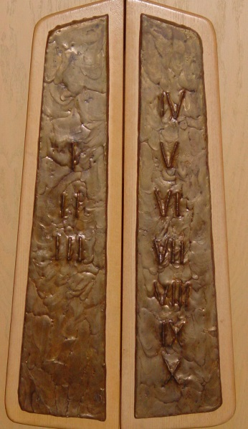
Ten Commandments

These remind us of the Law of God whose function, as Paul said is, “To bring us unto Christ; that we might be justified by faith.” (Galatians 3:24)
The two sets of aisle door handles thus remind us of the Law and Gospel, the two divisions of the Word of God.

Center Aisle Doors

Serving Us Today
Greeters: Keith and Audrey Lippert
Head Usher: Mark Zutz
Ushers: Bob Argall
Acolyte: Carter Valleskey
Lector: Bob Wigen
Sound Operator: Erin Lenzner and Lucas Spindler
Projection: Carter Lenzner and Addison Spindler

Serving Us Next Week
Greeters: Luke Evenson and Family
Head Usher: Scott Reinertson
Ushers: Brian and Mary Thomsen Family
Acolyte: DJ Schisel
Lector & Communion: Brian Ulness
Sound Operator & Live Stream: Bill Riesterer
Projection: Mitchell Zutz
Video Operator: Eric Thomsen

Last Week – Sunday - Sanctuary: 60 Video: 48 Wednesday: 58
Offerings to the Lord’s work: $5,108.00

Known to have been hospitalized or in need of prayer: Al Sebo, Gorman Lex, Lorraine Reindl, Delores Johnson, Cathy Luckow, Larry Madson, Ginger Linsmeier, Bob Klessig, Elling Jones (brother of Ron Jones), Julia Quinn (granddaughter of Julie Dehne), Merle “Butch” Graf, Wayne Allen Huske.

Please keep in your thoughts and prayers the following who are serving in the military: Darcie Bauknecht, Daniel Brandl, Matthew Brill, Kyle and Dylan Conrad, Corey Evenson, Mitchell Hazelwood, Carter Hildebrandt, Gary Hildebrandt, Jeff Konz, Justin Mertzig and Andy Schnell. If there are others we should be remembering, please inform the church office.

Faith’s Opportunities February 28-March 7
Sunday 10:00 A.M. Sunday School
Monday 5:00 P.M. Board of Lay Ministry
5:00 P.M. Jazzercise
6:00 P.M. Televised Worship
Tuesday 6:00 P.M. Board of Evangelism
Wednesday 5:00 P.M. Hands on Mission
6:15 P.M. Worship
Thursday 8:00 A.M. Quilting
5:00 P.M. Jazzercise
Sunday 8:00 A.M. Boards of Christian Ed & Youth
9:00 A.M. Worship
10:00 A.M. Sunday School

As part of our 60th year celebration of coming together as one congregation of Faith, each week we will look at the symbolism around our church sculpted by O. V. Schaffer.
Ten Commandments

These remind us of the Law of God whose function, as Paul said is, “To bring us unto Christ; that we might be justified by faith.” (Galatians 3:24)
The two sets of aisle door handles thus remind us of the Law and Gospel, the two divisions of the Word of God.

Center Aisle Doors

