Serving Us Today
Greeters: Earl and Barb Griffin
Head Usher: Mark Zutz
Ushers: Dean & Rose Behnke Family
Acolyte:
Lector: Garrett Ulness
Communion: Clarissa Ulness
Sound Operator: Bill Riesterer
Projection: Bill Riesterer and Whitney Ulness

Serving Us Next Week
Greeters: Keith and Audrey Lippert
Head Usher: Mark Zutz
Ushers: Bob Argall
Acolyte: Carter Valleskey
Lector: Bob Wigen
Sound Operator: Erin Lenzner and Lucas Spindler
Projection: Carter Lenzner and Addison Spindler

Last Week – Sunday - Sanctuary: 61 Video: 46 Wednesday: 81
Offerings to the Lord’s work: $5,644.00

Known to have been hospitalized or in need of prayer: The family of William Bratz Sr. whose funeral will be held here yesterday, Gorman Lex, Lorraine Reindl, Delores Johnson, Cathy Luckow, Larry Madson, Ginger Linsmeier, Bob Klessig, Elling Jones (brother of Ron Jones), Julia Quinn (granddaughter of Julie Dehne), Merle “Butch” Graf, Wayne Allen Huske.

Please keep in your thoughts and prayers the following who are serving in the military: Darcie Bauknecht, Daniel Brandl, Matthew Brill, Kyle and Dylan Conrad, Corey Evenson, Mitchell Hazelwood, Carter Hildebrandt, Gary Hildebrandt, Jeff Konz, Justin Mertzig and Andy Schnell. If there are others we should be remembering, please inform the church office.

Faith’s Opportunities February 21-28
Sunday 10:00 A.M. Sunday School
Monday 5:00 P.M. Jazzercise
6:00 P.M. Televised Worship
Wednesday 6:15 P.M. Worship
Thursday 8:00 A.M. Quilting
5:00 P.M. Jazzercise
Sunday 9:00 A.M. Worship
10:00 A.M. Sunday School

As part of our 60th year celebration of coming together as one congregation of Faith, each week we will look at the symbolism around our church sculpted by O. V. Schaffer.
The Sun of Righteousness
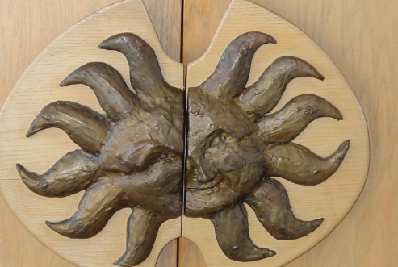
Door Pulls from Narthex into Inner Narthex
When Moses came down from Mt. Sinai with the two tablets containing the Ten Commandments, “The skin of his face shown because he had been talking with God.” (Exodus 34:29). Can there be a better reminder of what we may experience as we enter the sanctuary for worship than these nave door pulls with the radiant face?

We are also reminded of our blessed Lord on the Mount of Transfiguration – “And His face did shine as the sun.” (Mathew 17:2)

It also has reference to the prophecy, Malachi 4:2, “Unto you that fear My Name the sun of righteousness shall rise, with healing in its wings.” This is what we anticipate to receive in the experience of the Word and Sacraments.

