Serving Us at 7:00 am
Greeters: Whitney Ulness
Head Usher: Matt Krogh Usher: Mitchell Zutz
Acolyte: Peter Cigler Lector & Communion: Chloe Cigler
Sound Operators: Hunter Spindler and Kai Meyer Live Stream: Erin Lenzner
Projection: Kai Meyer Video Operator: Mike Lenzner
Serving Us at 9:00 am
Greeters: Richard and Linda Menza Head Usher: Delton Duchow
Usher: Ron Jones Acolyte: Makenna Kaderabek
Lector: Bob Wigen Communion: Stefanie Kaderabek
Sound Operator: Loren Ulness Live Stream: Kelly Meyer
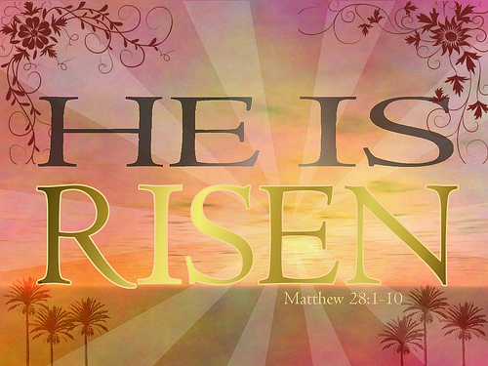
Projection: Luke Evenson Video Operator: Jake Kaderabek

Last Week – Sunday - Sanctuary: 88 Video: 57 Wednesday: 59
Offerings to the Lord’s work: $4,246.00

Known to have been hospitalized or in need of prayer: the family of Larry Madson whose funeral was held here yesterday, Roy Sebo, Gorman Lex, Lorraine Reindl, Delores Johnson, Cathy Luckow, Ginger Linsmeier, Bob Klessig, Elling Jones (brother of Ron Jones), Julia Quinn (granddaughter of Julie Dehne), Merle “Butch” Graf, Wayne Allen Huske.

Please keep in your thoughts and prayers the following who are serving in the military: Darcie Bauknecht, Daniel Brandl, Matthew Brill, Kyle and Dylan Conrad, Corey Evenson, Mitchell Hazelwood, Carter Hildebrandt, Gary Hildebrandt, Jeff Konz, Justin Mertzig and Andy Schnell. If there are others we should be remembering, please inform the church office.

April Stewardship is Baptism Quilts
Materials needed:
• 1½ yards of baby appropriate cotton material for top & bottom. Can
also be a baby flannel.
• 1½ yards of batting (either cotton or low loft). Can also be a crib size
45x60 in a bag.
Any cash or gift cards can be given to Christine in the office. Place any items in the Stewardship Cabinet across from the office.

The Annual Scouting for Food Drive is Saturday, April 17. On April 10 bags will be left on your door. Scouts will be out looking for bags of food starting at 8:00 a.m. on Saturday, April 17. Bags can be left on your doorstep or if you live outside of Valders, you can bring it to worship with you and place it on the table or shopping cart in the Gathering Space. Thank you for your help!

Faith’s Opportunities April 5-11
Monday Office closed
5:00 P.M. Board of Lay Ministry
6:00 P.M. Televised Worship & Jazzercise
Tuesday 6:00 P.M. Board of Evangelism
Wednesday NO Worship
Thursday 8:00 A.M. Quilting
6:00 P.M. Jazzercise
Saturday 9:00 A.M. Church grounds clean up
Sunday 8:00 A.M. Boards of Christian Ed and Youth
9:00 A.M. Worship
10:00 A.M. Sunday School

As part of our 60th year celebration of coming together as one congregation of Faith, each week we will look at the symbolism around our church sculpted by O. V. Schaffer.

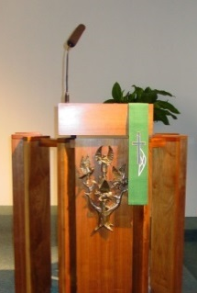
The Pulpit
From this pulpit the Word will be preached. The authors of the four Gospels have been the principle recorders of Christ’s life. The most common symbol for these four evangelists are:
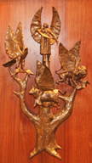
St. Mathew – winged man, for his Gospel begins with the human ancestry of Christ.

St. Mark – winged lion, for his Gospel opens with a description of the “voice of one crying in the wilderness.”

St. Luke – winged ox, for his Gospel gives the most complete account of the sacrificial death of Christ.

St. John – Eagle, for his Gospel soars heavenward.

These symbols have been mounted on a tree – the Tree of Life, or perhaps a Jesse Tree. (Isaiah 11:1) This verse has stimulated the imagination of artists for centuries. However, no two seem to use the same number of “branches”, nor do they include the same persons.

Thank you to the following that helped to beautify our altar area for Easter this morning.

In memory of Gilman, Grace and Elaine Peterson by Carolyn Coble, Geneva Corace and Jerry Peterson
In loving memory of Robert Meyer by Virginia Meyer and family
In special thanksgiving to God by Alan Gilbertson
In loving memory of Glenn and Tom Torrison, Orin and Clara Torrison, Victor and Regina Bronk, Norman Bronk and Marvin Bronk by Ruth Torrison and family
In memory of Ted, Betty and Bruce Jeske by The Jeske Family
In special thanksgiving to God by Joan Pritzl
In memory of Larry Backus by Jill Backus
In special thanksgiving for God’s Blessings by Michael and Marlene Zutz
In special thanksgiving to God for our healthy family by Jenniffer Zutz
In special thanksgiving to God by Don and Cheryl Domrath
In special thanksgiving to God by Ron and Kaye Jandrey
In memory of Glenn Thomsen, Fred and Marion Brockman, Peter and Helen Thomsen by Marlene Thomsen
In special thanksgiving to God by John and Kerry Schnell
In memory of Jim and Ramona Madson and Tara Sousek by Peggy Madson
In memory of Clarence and Annabelle Ott by Esther Halverson and family
In memory of Herman Halverson by Esther Halverson and family
In memory of our loved ones by Sue and Bill Riesterer
In special thanksgiving to God for our family by Dave and Terry Haupt
In memory of my grandparents by Scott Reinertson
In memory of Lynn’s mother, Marian Broich and Robert Burzynski by Laurance and Lynn Burzynski

World Hunger donations were given:
In memory of Edward Streckert by Janice Streckert and family
In memory of Marvin and Mabel Petersen, Raymond Rusch and Jay Hetland by Romelle Rusch

