Serving Us Today
Greeters: Richard and Linda Menza
Head Usher: Tom Madson
Ushers:
Acolyte: Addison Spindler
Lector: Jenniffer Zutz
Communion Aide: Bobbi Jo Robley
Sound Operator: Loren Ulness
Projection: Carter Lenzner

Serving Us Next Week
Greeters: Brian and Mary Thomsen Family
Head Usher: Tom Madson
Ushers: Tom and Kathy Muench
Acolyte: Peter Cigler
Lector: Joan Pritzl
Sound Operator: Loren Ulness
Projection:

Last Week – Sunday-Sanctuary: 126 Video: 21 Wednesday: 47
Offerings to the Lord’s work: $8,101.00

Known to have been hospitalized or in need of prayer: the family of Sandra Lemberger upon the loss of her sister Debbie Riesterer, Delores Johnson, Cathy Luckow, Larry Madson, Ginger Linsmeier, Bob Klessig, Elling Jones (brother of Ron Jones), Merle “Butch” Graf, Wayne Allen Huske.

Please keep in your thoughts and prayers the following who are serving in the military: Darcie Bauknecht, Daniel Brandl, Matthew Brill, Kyle and Dylan Conrad, Corey Evenson, Mitchell Hazelwood, Carter Hildebrandt, Gary Hildebrandt, Jeff Konz, Justin Mertzig and Andy Schnell. If there are others we should be remembering, please inform the church office.

DVDs are available of Walk Through Bethlehem and the Sunday School Christmas program. Please contact the office or pick one up at the welcome desk. The videos will also be posted on the church website and YouTube channel.

Faith’s Opportunities December 21-27
Monday 6:00 P.M. Jazzercise & Televised Worship
6:30 P.M. Council meets
Wednesday NO Worship
Thursday Christmas Eve Worship at 1, 3, 5, & 10:00pm
Friday Christmas Day Worship at 10:00 am
Sunday 9:00 A.M. Worship

Starting in January 2021 through May 2021, Sunday School will begin at 10:00 am and end at 11:00 am.

Soup for the Souls recently made a batch of chili. If you know of someone who could benefit from a warm bowl of soup, please take a container to them. Containers are in the freezer in the Gathering Space.

Assistance is needed on Christmas Eve during the service. We are in need of a sound operator and projectionist at the 1:00 pm service, ushers at the 3:00 service and an acolyte and greeters at the 10:00 pm service. If you can help, please let Pastor Jim know or call Christine in the office at 775-4141. Thank you.

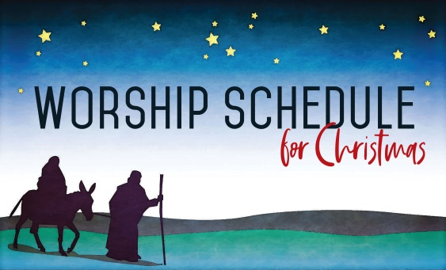

Christmas Eve Worship is at 1:00, 3:00, 5:00 and 10:00 pm. NO COMMUNION.

Christmas Day Worship is at 10:00 am. with Holy Communion
Serving Us Today
Greeters: Richard and Linda Menza
Head Usher: Tom Madson
Ushers:
Acolyte: Addison Spindler
Lector: Jenniffer Zutz
Communion Aide: Bobbi Jo Robley
Sound Operator: Loren Ulness
Projection: Carter Lenzner

Serving Us Next Week
Greeters: Brian and Mary Thomsen Family
Head Usher: Tom Madson
Ushers: Tom and Kathy Muench
Acolyte: Peter Cigler
Lector: Joan Pritzl
Sound Operator: Loren Ulness
Projection:

Last Week – Sunday-Sanctuary: 126 Video: 21 Wednesday: 47
Offerings to the Lord’s work: $8,101.00

Known to have been hospitalized or in need of prayer: the family of Sandra Lemberger upon the loss of her sister Debbie Riesterer, Delores Johnson, Cathy Luckow, Larry Madson, Ginger Linsmeier, Bob Klessig, Elling Jones (brother of Ron Jones), Merle “Butch” Graf, Wayne Allen Huske.

Please keep in your thoughts and prayers the following who are serving in the military: Darcie Bauknecht, Daniel Brandl, Matthew Brill, Kyle and Dylan Conrad, Corey Evenson, Mitchell Hazelwood, Carter Hildebrandt, Gary Hildebrandt, Jeff Konz, Justin Mertzig and Andy Schnell. If there are others we should be remembering, please inform the church office.

DVDs are available of Walk Through Bethlehem and the Sunday School Christmas program. Please contact the office or pick one up at the welcome desk. The videos will also be posted on the church website and YouTube channel.

Faith’s Opportunities December 21-27
Monday 6:00 P.M. Jazzercise & Televised Worship
6:30 P.M. Council meets
Wednesday NO Worship
Thursday Christmas Eve Worship at 1, 3, 5, & 10:00pm
Friday Christmas Day Worship at 10:00 am
Sunday 9:00 A.M. Worship

Starting in January 2021 through May 2021, Sunday School will begin at 10:00 am and end at 11:00 am.

Soup for the Souls recently made a batch of chili. If you know of someone who could benefit from a warm bowl of soup, please take a container to them. Containers are in the freezer in the Gathering Space.

Assistance is needed on Christmas Eve during the service. We are in need of a sound operator and projectionist at the 1:00 pm service, ushers at the 3:00 service and an acolyte and greeters at the 10:00 pm service. If you can help, please let Pastor Jim know or call Christine in the office at 775-4141. Thank you.

Christmas Eve Worship is at 1:00, 3:00, 5:00 and 10:00 pm. NO COMMUNION.

Christmas Day Worship is at 10:00 am. with Holy Communion

