**Serving Us Today**

Greeter: Wayne Huske Head Usher: Scott Reinertson

Usher: Lori Propson Acolyte: Mollie Junk

Lector: Ava Ulness

Sound Operator and Projection: Terry Huske

Video and Live Stream: Carter Lenzner

**Serving Us Next Week**

Greeters: Brian and Mary Thomsen family Head Usher: Scott Reinertson

Ushers: Mitchell Zutz Acolyte: Gage Spindler

Lector: Jenniffer Zutz

Video and Live Stream: Eric Thomsen Projection: Stefanie Kaderabek

Sound Operator: Makenna Kaderabek

Last Week – Sunday: 64 Video: 72 Wednesday: 40

Offerings to the Lord’s work: $4,531.00

**Known to have been hospitalized or in need of prayer:** Donald Tienor, Lorraine Reindl, Delores Johnson,Cathy Luckow, Ginger Linsmeier, Bob Klessig, Andrew and Danielle Madson and their unborn son Ivan, Ronald Christianson, Elling Jones (brother of Ron Jones), Merle “Butch” Graf, Wayne Allen Huske.

**Please keep in your thoughts and prayers the following who are serving in the military:** Daniel Brandl, Matthew Brill, Kyle and Dylan Conrad, Corey Evenson, Mitchell Hazelwood, Carter Hildebrandt, Jeff Konz, Justin Mertzig and Andy Schnell. If there are others we should be remembering, please inform the church office.

*We are looking for our adult members to guide our kids on their Sunday School journey! Here is how you can help:*

● Sign up to lead the kids in areas YOU are comfortable - sharing a

Bible story, leading a craft, singing a song or playing a game. Each

week, 3-4 adult leaders will teach one of these elements to 3

different groups that rotate through a station.

● No major commitment required! Sign up on the calendar outside the

Youth Office or online (via a link to a Google Sheet) for the

Sunday/s that work for YOUR schedule. You may sign up for as

many or as few Sundays that you are available.

● All lesson plan ideas will be provided. You can pick up the lesson

plan anytime so you can look it over and be ready for Sunday

School.

We hope to have many adults (and kids!) be part of Sunday School. Invite your friends! If you have questions, contact: Chloe Cigler 920-860-6864, Stefanie Kaderabek 920-901-4878, Anderia Frank 920-973-4658.

**Faith’s Opportunities August 22-29**

**Sunday** 10:00 A.M. Fellowship Hour

**Monday** 6:00 P.M. Televised Worship/Jazzercise

**Wednesday** 6:15 P.M. Worship

**Thursday** 8:00 A.M. Quilting

6:00 P.M. Jazzercise

**Sunday** 9:00 A.M. Worship

10:00 A.M. Fellowship Hour

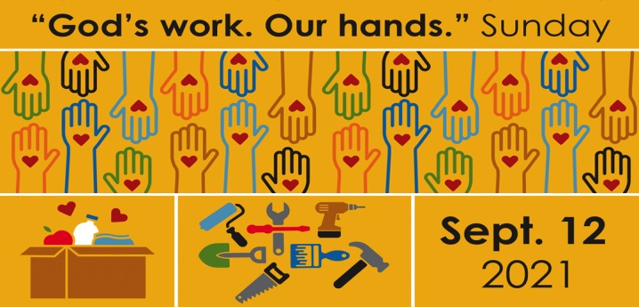

Sign up for Faith’s “God’s Work. Our Hands” event in the Gathering Space. This event begins following worship on Sunday, September 12th. A bag lunch will be provided and the Packers have cooperated with a scheduled 3:25 PM game. Please take time to discern your gifts and passions and commit to a time of giving to others.



**Sunday school starts September 19th** with the theme “Round ‘em Up for Jesus”. Fellowship is putting on a **brunch after worship at 10:00**. Please sign up at the Information Desk so we know how many to plan for. This is a great way to kick-off the year. **The children will head to class after they eat.** Then we will hear more about the exciting new plan for Sunday school.

**Serving Us Today**

Greeter: Wayne Huske Head Usher: Scott Reinertson

Usher: Lori Propson Acolyte: Mollie Junk

Lector: Ava Ulness

Sound Operator and Projection: Terry Huske

Video and Live Stream: Carter Lenzner

**Serving Us Next Week**

Greeters: Brian and Mary Thomsen family Head Usher: Scott Reinertson

Ushers: Mitchell Zutz Acolyte: Gage Spindler

Lector: Jenniffer Zutz

Video and Live Stream: Eric Thomsen Projection: Stefanie Kaderabek

Sound Operator: Makenna Kaderabek

Last Week – Sunday: 64 Video: 72 Wednesday: 40

Offerings to the Lord’s work: $4,531.00

**Known to have been hospitalized or in need of prayer:** Donald Tienor, Lorraine Reindl, Delores Johnson,Cathy Luckow, Ginger Linsmeier, Bob Klessig, Andrew and Danielle Madson and their unborn son Ivan, Ronald Christianson, Elling Jones (brother of Ron Jones), Merle “Butch” Graf, Wayne Allen Huske.

**Please keep in your thoughts and prayers the following who are serving in the military:** Daniel Brandl, Matthew Brill, Kyle and Dylan Conrad, Corey Evenson, Mitchell Hazelwood, Carter Hildebrandt, Jeff Konz, Justin Mertzig and Andy Schnell. If there are others we should be remembering, please inform the church office.

*We are looking for our adult members to guide our kids on their Sunday School journey! Here is how you can help:*

● Sign up to lead the kids in areas YOU are comfortable - sharing a

Bible story, leading a craft, singing a song or playing a game. Each

week, 3-4 adult leaders will teach one of these elements to 3

different groups that rotate through a station.

● No major commitment required! Sign up on the calendar outside the

Youth Office or online (via a link to a Google Sheet) for the

Sunday/s that work for YOUR schedule. You may sign up for as

many or as few Sundays that you are available.

● All lesson plan ideas will be provided. You can pick up the lesson

plan anytime so you can look it over and be ready for Sunday

School.

We hope to have many adults (and kids!) be part of Sunday School. Invite your friends! If you have questions, contact: Chloe Cigler 920-860-6864, Stefanie Kaderabek 920-901-4878, Anderia Frank 920-973-4658.

**Faith’s Opportunities August 22-29**

**Sunday** 10:00 A.M. Fellowship Hour

**Monday** 6:00 P.M. Televised Worship/Jazzercise

**Wednesday** 6:15 P.M. Worship

**Thursday** 8:00 A.M. Quilting

6:00 P.M. Jazzercise

**Sunday** 9:00 A.M. Worship

10:00 A.M. Fellowship Hour



Sign up for Faith’s “God’s Work. Our Hands” event in the Gathering Space. This event begins following worship on Sunday, September 12th. A bag lunch will be provided and the Packers have cooperated with a scheduled 3:25 PM game. Please take time to discern your gifts and passions and commit to a time of giving to others.



**Sunday school starts September 19th** with the theme “Round ‘em Up for Jesus”. Fellowship is putting on a **brunch after worship at 10:00**. Please sign up at the Information Desk so we know how many to plan for. This is a great way to kick-off the year. **The children will head to class after they eat.** Then we will hear more about the exciting new plan for Sunday school.