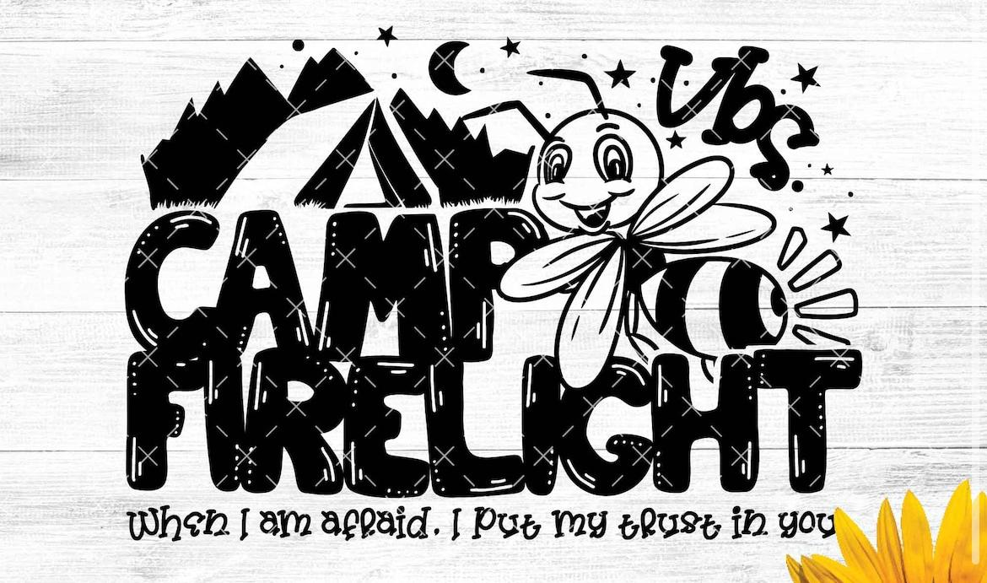

Dear Families,

At Camp Firelight VBS, students will enjoy an interactive, energizing, Bible-based good time on their summer camp adventure with God. They will become Campers and discover how to put their trust in God in every situation. After a high-energy Opening Assembly time, the Campers will make their way to the various stations. The Bible Story Station reveals each Firelight Focus to equip your Campers for an active life with God. Firelight Focus (Bible memory verse) will remain with them in their faith long after VBS. The students will expand on what they’ve discovered by making art projects at the Craft Station, exploring the wonders of God’s creation at the Science Station, playing games at the Recreation Station, and enjoying tasty treats at the Snack Station. Join us as we discover how to put our trust in God in every situation!

Place: Faith Lutheran Church Valders, WI
Date: Monday June 17th through Thursday June 20th
Time: 12:30 - 4pm (Join us for group songs daily at 3:45 in the church)
Cost: $20/camper ($40 max/family) VBS camperships are available if needed.
Ages: Entering 4K through 6th grade. All denominations are welcome!

The week will conclude with a Family Campfire and Movie Night. Friday June 21st 8pm (weather permitting). More details to come!

Please drop off or mail forms and payment to:
Faith Lutheran Church 255 Roosevelt St Valders, WI 54245
Registration ends May 31st!!
Please reach out to our Youth Coordinator with any questions valleskeyb@gmail.com 920-905-5273

Sincerely, Your Camp Firelight VBS Team

Vacation Bible School Registration Form (one form per child)

Child’s Name: ________________________________________________________________
Child’s Gender: ________ Child’s Age: _________ Date of Birth: ________________________
School grade completed in 2023-2024: _______
Name of parent(s): ____________________________________________________________________________
Street Address: ____________________________________________________________________________
City: ____________________________________ State: ____________ ZIP Code:__________ _________________ Home Phone: (_______) ______________________
Cell Phone: (_______) ______________________
Email Address: ____________________________________________________________________________ Home Church: ____________________________________________________________________________ Medical conditions: ____________________________________________________________ Food Allergies:________________________________________________________________ In case of emergency during VBS, contact:__________________________________________
Phone: ________________________ Relationship to child:_____________________________

Do we have permission to use your child’s picture in publicity photos? YES NO (circle one)

Please check one:
□ My child is attending Summer School at Valders and WILL ride the bus from Valders Elementary School to Faith Lutheran Church. I will make sure they have transportation home at 4:00.
□ I will make my own arrangements for transportation of my child to and from Faith Lutheran Church.

